authors instructions for abstracts for The 7th international TEXTEH conference
7th TEXTEH International conference
Bucharest, Romania, October 22-23, 2015

First A. Author1, Second B. Author2 and Third C. Author3
¹ National R&D Institute for Textiles and Leather Bucharest (INCDTP)
16Lucretiu Patrascanu, 030508 Bucharest, Romanaia
e-mail: certex@ns.certex.ro, webpage: http://www.certex.ro

Keywords: Coating, PCM, ….

ABSTRACT
This document presents the information and instructions needed to prepare the extended abstract to be included in the proceedings of the 6th International TEXTEH Conference. All abstracts and papers should be written in English. In order to achieve graphical consistency, the extended abstract and paper should be written using Microsoft Word. The abstract should start with the paper’s title, authors, first author affiliation, address, e-mail and webpage, followed by keywords (up to six). The typeface used for the abstract is a 12 point Times-Roman. The word Abstract, written in 12 point bold Times-Roman, must appear before the abstract text.
The abstract length should be kept within two pages. It is possible to include tables, graphics or pictures in the extended abstract, see Figure 1. However, notice extended abstracts will be published in black/white.
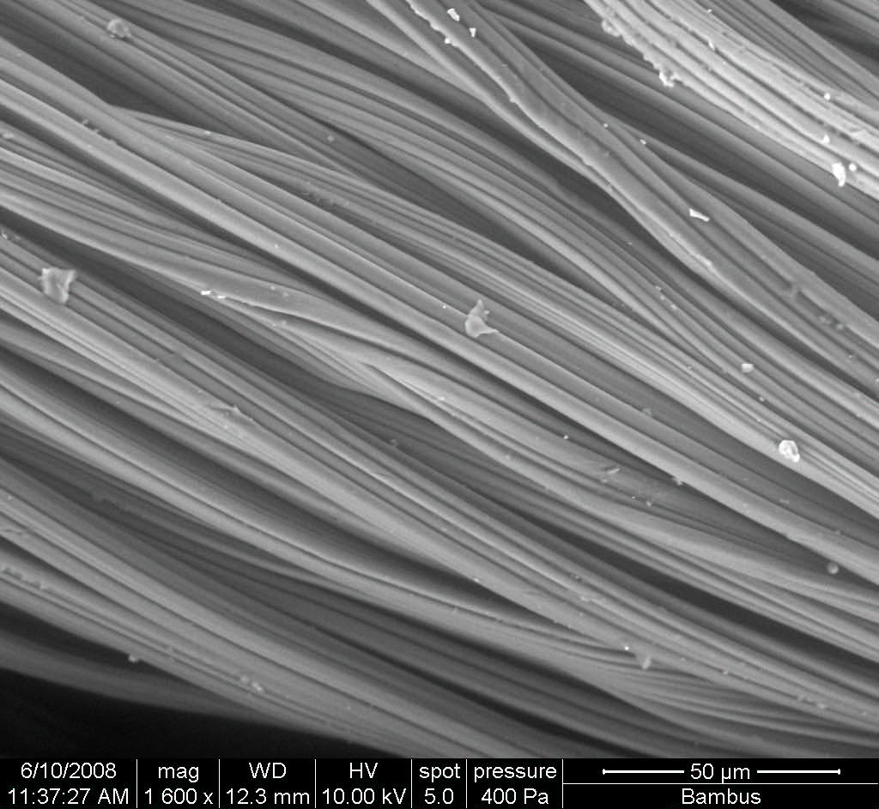
Figure 1: SEM image of bamboo fibers

